**VELAMMAL BODHI CAMPUS**

**CUMULATIVE EXAM - I (2023-24)**

**CLASS : X ENGLISH MARK : 80**

**DATE : 04.05.2023 TIME : 3Hrs**

**SECTION A (READING) (20 MARKS)**

* 1. **Read the text carefully and answer the questions: (10)**
     1. Marie Curie was one of the most accomplished scientists in history. Together with her husband, Pierre, she discovered radium, an element widely used for treating cancer, and studied uranium and other radioactive substances. Pierre and Marie's amicable collaboration later helped to unlock the secrets of the atom
     2. Marie was born in 1867 in Warsaw, Poland, where her father was a professor of physics. At an early age, she displayed a brilliant mind and a blithe personality. Her great exuberance for learning prompted her to continue with her studies after high school She became disgruntled, however, when she learned that the university in Warsaw was closed to women. Determined to receive a higher education, she defiantly left Poland and in 1891 entered the Sorbonne, a French university, where she earned her master's degree and doctorate in physics.
     3. Marie was fortunate to have studied at the Sorbonne with some of the greatest scientists of her day, one of whom was Pierre Curie. Marie and Pierre were married in 1895 and spent many productive years working together in the physics laboratory. A short time after they discovered radium. Pierre was killed by a horse-drawn wagon in 1906.

Marie was stunned by this horrible misfortune and endured heartbreaking anguish. Despondently, she recalled their close relationship and the joy that they had shared in scientific research. The fact that she had two young daughters to raise by herself greatly increased her distress.

* + 1. Curie's feeling of desolation finally began to fade when she was asked to succeed her husband as a physics professor at the Sorbonne. She was the first woman to be given a professorship at the world-famous university. In 1911, she received the Nobel Prize in chemistry for isolating radium. Although Marie Curie eventually suffered a fatal illness from her long exposure to radium, she never became disillusioned about her work Regardless of the consequences,

she had dedicated herself to science and to revealing the mysteries of the physical world.

* + - 1. According to the author, what made Marie Curie the ever-existing name in the world of science?
      2. What message does the phrase 'she never became disillusioned about her work' convey?
      3. What qualities did Perrie and Marie show when they worked together? Choose one option from the following:
         1. Incompatibility b. envy c. camaraderie d. Jealousy
      4. Select the option with the underlined words that can suitably replace 'desolation' (paragraph IV).
         1. She was in gloom when her father left her all alone.
         2. Riya was so elated to know that she passed the test.
         3. The teacher was so strict while invigilating in the exam hall.
         4. Mohan is a destitute boy who keeps worrying about his future all the time.
      5. Marie had a 'blithe' personality. Substitute the word 'blithe' with ONE WORD.
      6. Identify the qualities of Marie Curie, according to the given passage.

1. determined (2) brilliant (3) carefree (4) quarrelsome (5)immoral
   1. (1), (2), (3) b. (4) and (5) c. (1),(4) and (5) d. (2) and (3)
      * 1. Identify the tone in the given phrase- 'Marie was stunned by this horrible misfortune'.
        2. Choose the option that lists the quote best expressing the central idea of the given passage.
           1. The backbone of success is hard work, determination and perseverance.
           2. Do not stop working; work is the only key to success.
           3. Nothing grows but honesty and hard work.
           4. Hard work pays off.
        3. Marie and Pierre were married in 1897 and spent many productive years working together in the physics laboratory. (True/false)

x. Complete the given analogy correctly with a word from the passage. Productive :

unproductive:: grouped :

## Read the text carefully and answer the questions: (10)

* + 1. Millions of tons of small waste from plastic bags, bottles and clothes in the world's oceansw present a serious threat to human health and marine environment. This is a warming issued by the U.N. in a report on the most dangerous

environmental problem facing the world today. Global plastic production has increased considerably in years nearly by 38%.

* + 1. A poor waste management means when we have finished with our takeaways contains cigarette butts and party balloons, they are worn down into trillions of even small particles by the waves. Therefore, there is a growing presence of these microplastic the world's oceans.
    2. It was estimated in 2010 that millions of tons of plastic were washed into the season have since shown up in the stomachs of whales, plankton and other marine life. Richard Thompson, professor of marine biology said that in laboratory experiments the proof that microplastic can cause harm to organisms.
    3. More than a quarter of all fish now contained plastic, according to a recent study while analyzing the guts of fish sold in California. Scientists fear that chemicals in plastician also chemicals which attach themselves to plastic in natural environment could each poisoning and many disorders in marine life if consumed in huge quantities.
    4. Even humans could be adversely affected by the plastic. People could even be breathing in plastic micro-particles suspended in the air with the risk of harmful effects on the lungs similar to air fumes.

6.Volunteers around the world collect trash and tally up what they find on the fall in Ocean's

Conservancy's Annual International Coastal Cleanup. The result item-by-item, location-by

location Ocean Trash Index provides the only snapshot of marine debris littering coasts and

waterways around the world, according to Ocean Conservancy.

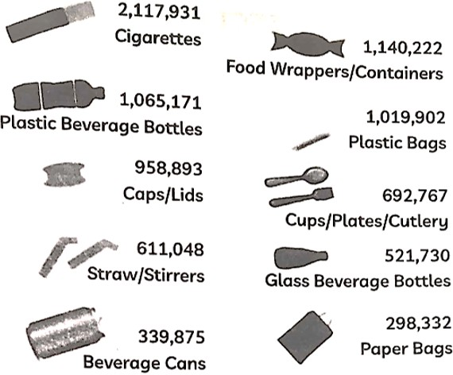

7. Boyance Slat, a Dutch student has developed a technology that could sift dangerous plastic particles out of the ocean and sell them for profit or re-cycling. Richard Thompson recommended that people avoid using products with micro beads and to make sure they dispose of all plastic products in an appropriate way by, if possible.

* + - 1. Select the option that is true for the two statements given below.

1. More than a quarter of all fish now have plastics present in them.
2. Millions of tons of plastic waste is present in the world's oceans.
   1. (1) is the result of (2) b. (1) is the reason for (2)

c. Both (1) and (2) are true d. (1) contradicts (2)

* + - 1. According to the passage, Richard Thompson is a .
      2. provides the only snapshot of marine debris littering coasts and waterways.
      3. Through what do the cigarette butts and party balloons wear down into smaller particles?
      4. We can find out that more than a quarter of all fish contained plastics in them by:
         1. the stark warming issued by the UN in a report on the most dangerous environmental problems facing the world today.
         2. collecting trash and tallying up what they find each day.
         3. laboratory experiments performed by Richard Thompson a profession marine biology.
         4. analyzing the fish sold in California.
      5. Choose the correct set of statement which is NOT TRUE.

1. Plastic could have similar effects like car fumes.
2. Chemicals which attach themselves to plastic in natural environment could cause poisoning in marine life.
3. Humans will never be adversely affected by the plastic.
4. In 2001, Millions of tons of plastic were washed into the sea.
5. There is a growing presence of microplastics in the world's oceans.
   1. (II), (V) b. (I), (V) c. (I), (II) d. (III), (IV)
      * 1. What amount of paper bags in the index are diffused into the oceans?
        2. Fill in the blank with the correct option.

There are ________________beverage cans found in the index.

* + - * 1. 337,865 b. 339,875 c. 339,445 d. 333,347
      1. Richard Thompson has recommended to use a product that has no micro-beads of plastic into them. True / False.
      2. How can the technology developed by Beyonce Slat help to curb the plastic issue?

# **SECTION B –GRAMMAR (12)**

* 1. Fill in the blank by choosing the correct option to complete the following.

Yasini is trying to on junk food as she has started to put on weight.

1. cut in b) cut down c) cut up d) cut across
   1. Report the dialogue between a father and son, by completing the sentence:

Son: Are you not excited about the trip, dad?

Father: I have been to Australia before.

In response to the question about being excited about the trip, the father says that_______________.

* 1. Select the correct option to fill in the blank for the given line about a key quality of teachers. A good teacher ________ be like as much as possible a bad student.

1. should b) ought to c) must d) will
   1. Identify the error in the given sentence, from an e-zine report and supply the correction. Anxiety is a manifestation of the mind being afraid of venture into the unknown.

Use the given format for your response.

|  |  |
| --- | --- |
| error | correction |
|  |  |

* 1. How bad that game is! I’m sure our team ____________in this match.

1. is being beaten b) will have been beaten c) is beaten d) is going to be beaten
   1. Fill in the blank by using the correct form of the word in the bracket, for the given portion of a letter:

As very little information is available about this course, I __________(be) extremely grateful if you could send me detailed information about it.

* 1. Report the dialogue between Sonu and doctor, by completing the sentence:

Sonu: How is she doing doctor?

Doctor: Your mother will recover quickly.

In response to the question about the well-being of Sonu’s mother, the doctor said that ____ .

* 1. Identify the error and supply the correction, for the following:

**DELHI GOVERNMENT**

**COVID-19 FAMILY FINANCIAL ASSISTANCE SCHEME**

An assistance of ₹2,500/- per month will be given to family residing in Delhi where earning members died due to COVID-19.

Use the given format for your response.

|  |  |
| --- | --- |
| error | correction |
|  |  |

* 1. The manager while assigning a new task to our team asked something about a previous project. Report the manager’s question.

Have you finished the project yet?

* 1. Select the correct option to fill in the blank for the given quote from a motivational speaker. It’s never too late to be who you .

1. could be b) might have been c) could have been d) should have been
   1. He said, "What a beautiful scene!"

## Reported speech:

1. He exclaimed that it was a very beautiful scene.
2. He wondered that it was a beautiful scene.
3. He said that what a beautiful scene it was.
4. He exclaimed what a beautiful scene it was.
   1. Identify the error in the given sentence, from a report from the News for Kids site and supply the correction. Bee bus stops are a small step toward support important pollinating insects.

Use the given format for your response.

|  |  |
| --- | --- |
| error | correction |
|  |  |

# 

# **SECTION B – CREATIVE WRITING SKILLS**

15. A. Write a letter to the editor of 'The Hindustan Times', Kasturba Gandhi Marg, New Delhi advocating the need for people to obey traffic rules for safety, to be law-abiding citizens, to wear helmets and to put on seat belts when driving on road.  **(4)**

# **OR**

B. You are the librarian of Delhi Jain Public School, Palam. You are instructed to buy some academic and reference books for the library. While browsing some good publishers over the internet you landed on the website of Oxford University Press, India and found this information there.

The ACADEMIC and REFERENCE programmes publish across a range of subjects. Books on economics and business, history, politics, law, and literature as well as philosophy and religion, sociology and

anthropology, and gender studies reach out to students, teachers, researchers, professionals, and general readers. Online services and student-friendly textbooks are recent additions. Cutting across age and reading habit, key focus areas in GENERAL books include arts and architecture, wildlife and natural history, culture, media studies and cinema, Indian writing in translation, and ecology and environment.

Write a letter to Oxford University Press, Ghaziabad, placing an order for books. Mention at least 4 titles of the books to be supplied immediately. Address yourself as Kalpana.

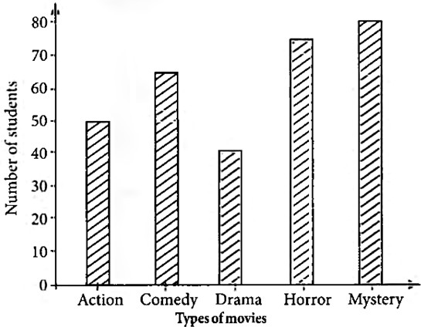16. A. The given bar graph shows the favourite genre of movies of students in a school. Write an analytical paragraph summarising the information and make comparisons wherever relevant.  **(4)**

# **OR**

B**. The following table shows details about the internet activities for six categories for different age groups. Write an analytical paragraph for the table given in around 150-200 words.**

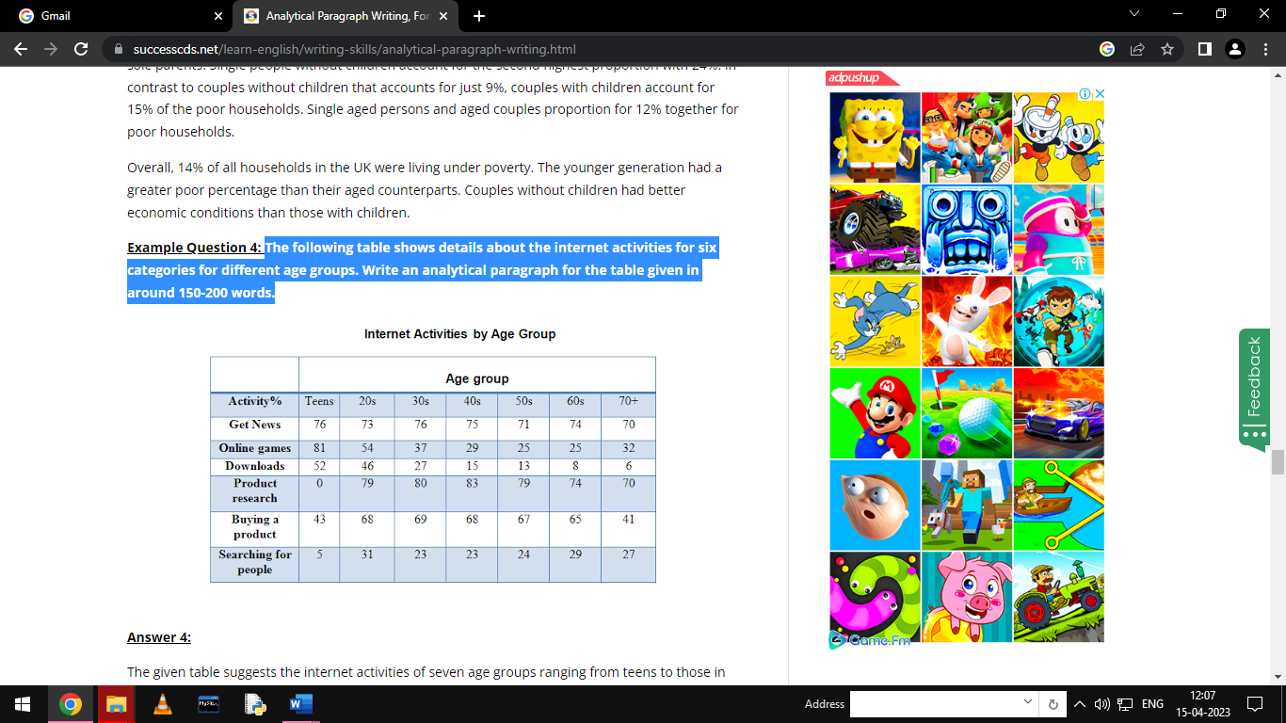

# **SECTION C - LITERATURE**

## 17. A. Read the text carefully and answer the questions: (5X1=5)

Lencho showed not the slightest surprise on seeing the money; such was his confidence - but he became angry when he counted the money. God could not have made a mistake, nor could he have denied Lencho what he had requested.

1. Why did Lencho get angry?
   1. Because his letter was misplaced by the postal service
   2. Because there was no reply from God to Lencho's letter
   3. Because there was less money than he asked for in the letter
   4. Because God's response to Lencho's letter was brief
2. Why was Lencho not surprised?
3. According to Lencho could not have made a mistake, nor could he have denied Lencho what he had requested.
4. Which word means the same as faith?
   1. Confidence b. Angry c. Requested d. Surprise
5. Lencho was not surprised on:
   1. seeing the letter b. seeing an empty envelope

c. seeing the money d. seeing the postmaster

**OR**

B. Eager to get away from crowded London he took a train to the village of Iping, where he booked two rooms at the local inn. The arrival of a stranger at an inn in winter was in any case an unusual event. A stranger of such uncommon appearance set all tongues wagging, Mrs. Hall, the landlord’s wife, made every effort to be friendly.

(a) After escaping from London, where did Griffin go?

(b) What did he experience there?

(c) Which phrase in the above extract means the same as ‘everybody started talking about him’?  
(d) How did the landlord’s wife behave?

(e) What is an unusual event?

## 18. A. Read the text carefully and answer the questions: (5X1=5)

Don’t bite your nails, Amanda!

Don’t hunch your shoulders, Amanda! Stop that slouching and sit up straight Amanda!

1. is the poet of the above lines.
2. What is Amanda asked not to do?
   1. Bite her nails b. Sit lazily c. Bent her shoulders d. All of these
3. What is the meaning of slouching?
   1. Sitting or lying in a lazy drooling manner b. Screaming

c. Eating compulsively d. Sitting erect

1. Amanda thought she could lead her life in a if she were a mermaid.
2. What does Amanda do to her shoulders?
   1. Keep them erect b. Hunches c. Keep them stiff d. Keep them loose

**OR**

**B. Read the text carefully and answer the questions:**

The way a crow

Shook down on me

The dust of snow

From a hemlock tree

1. Birds are a beautiful creation of nature but we associate them with different references. Complete the analogy in this context.

Dove : Positive (Peace) :: Crow :

1. Which tree did the crow shake?
   1. Banyan b. Hemlock c. Mango d. pine
2. What fell on the poet while he was sitting under the tree?
   1. snow flakes b. flowers c. dried leaves d. dust
3. What does the Hemlock tree refer to metaphorically?
4. What is the dust of snow?
   1. Snow that settles on the surface b. Snowfall

c. Dust particles in environment d. None of these

**19. Answer ANY FOUR of the following in about 40-50 words each. (4X3=12)**

1. How can you distinguish between a tiger and a leopard?
2. Why does the poet think that it is useless to give the following suggestion to the boy? ‘No use to say- ‘O there are other balls’:

iii. Fear and lack of confidence stop one from learning new things. Do you agree? How did these two traits of the young seagull make him a coward? How did he overcome these short comings?

iv. What did Mandela think for oppressor and oppressed?

v. Why does Anne Frank think that ‘paper’ has more patience than ‘people’?

**20. Answer ANY TWO of the following in about 40-50 words each. (2X3=6)**

i. What would you have done if you were in the place of James Herriot?

ii. How did Ausable get rid of Max?

iii. What happened to Jaffers when he tried to catch the invisible scientist?

**21. Answer ANY ONE of the following in about 100-120 words. (6)**

i. Read the extracts given below and comment on the difference in the nature of help both the

characters, of these two stories, received.

* 1. Suddenly I came out of the clouds and saw two straight lines of lights in front of me. It was a runway! An airport! I was safe! I turned to look for my friend in the black aeroplane but the sky was empty. [The Black Aeroplane]
  2. All through the night Lencho thought only of his one hope: the help of God...The following Sunday, at daybreak he began to write a letter...It was nothing less than a letter to God...The following Sunday Lencho came a bit earlier than usual to ask if there was a letter for him.Lencho showed not the slightest surprise on seeing the money, such was his confidence. [A Letter to God]

**OR**

**ii. There are many ideas about how the world will ‘end’. Do you think the world will end some day? Have you ever thought what would happen if the sun got so hot that it ‘burst’, or grew colder and colder?**

1. **Answer ANY ONE of the following in about 100-120 words. (6)**
2. How did Anil lead his life? What was his profession? Why was Anil ready to have Hari Singh as a servant?

**OR**

1. Imagine that the young lady thief writes a letter to Horace Danby while he is in prison. Write the letter imagining yourself to be that young lady with respect to the story.